**PLEXR X-BOOST**

Plexr X-Boost is a feature that we are planning to introduce in Plexr to boost the process of getting the Plexr experience 10x sooner than what we have now. The main goals of this function is to make the user

1. Experience Plexr sooner
2. Invite friends at their own will.

When a user signs up for the first time, after the phone number verification screen we will take them to the chat screen as shown below. That chat window will belong to the user itself. If the user posts content in that chat window, they can open it and leave a reaction to themselves. That chat window will be only for that user. Initially the chat window will have content (just 1) in it as shown below.

This Back button will be hidden from the user until this entire process is complete so the user will have to watch the video before they go back.

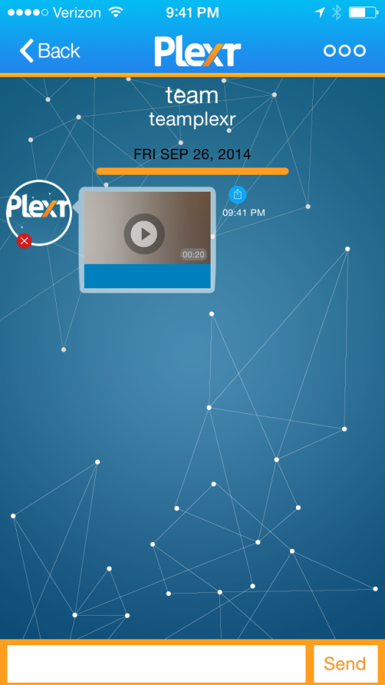

This play sign will have some type of animation. It can be blinking or rotating or something. The purpose is to get the user to tap that play

After they tap the play button, we will play the content (not more than 30 seconds). The content will be chosen randomly for each user from our database. (To developer: We will provide the videos for you). We will capture their reaction while they watch the content and upload the reaction into the chat window. That reaction can be viewed only by that user. When the reaction is uploaded we will show this screen.

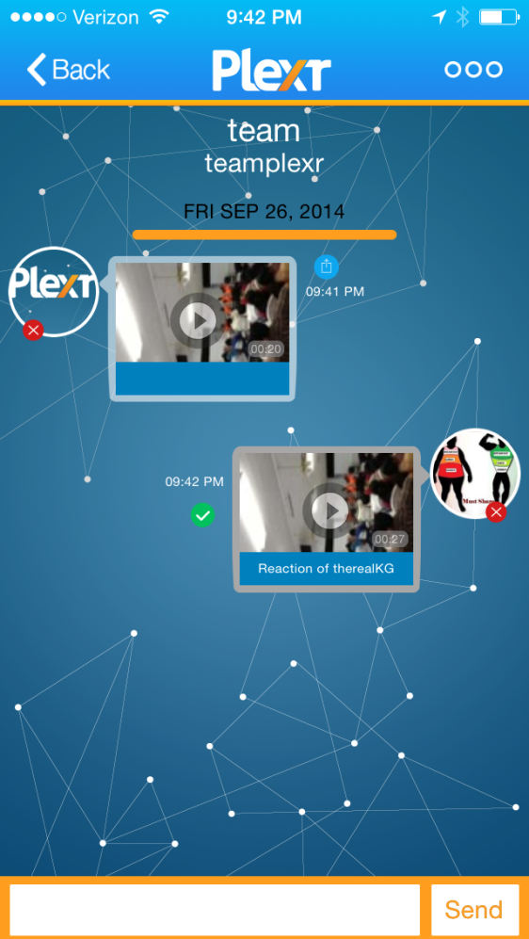

This Back button will be hidden from the user until this entire process is complete so the user will have to watch the video before they go back.

Once we upload the reaction video we will animate the play button on the reaction video the same way to make the user click on it.

When they click on the reaction we will play the reaction video so they can experience their reaction first. After they view their reaction we will show this screen.

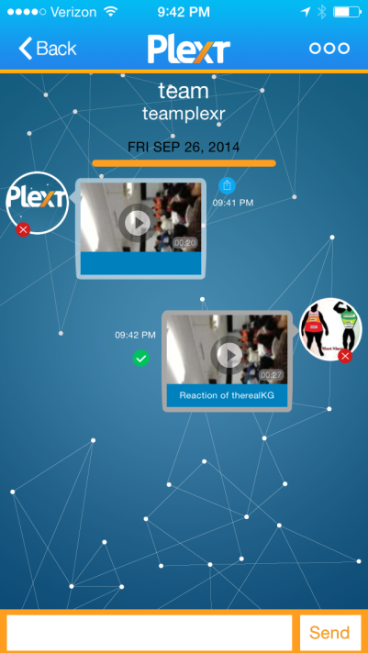

After they play the reaction video we will animate the share button and try to make the user click on it.

The purpose of this screen is to make them invite their friends to Plexr. Since they experienced Plexr within themselves, assuming they want to see their friend’s reaction, they would share this content to Both Plexr users and non Plexr users. When they hit that button we will show them the share preview screen followed by the friends selection screen. After they select the friends and share this content, we will take them to the home screen.

After they re-share the content with friends, we will show them the home screen, with the “I” animated.

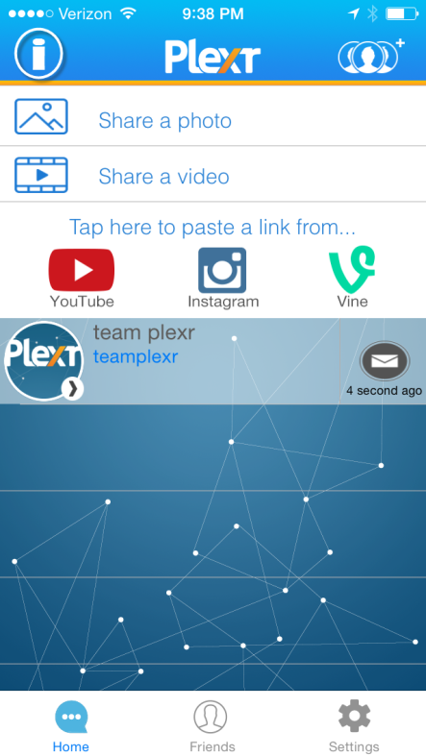

The purpose of this screen is to show them the tutorial screens that will let them know that they can and how to share content from YouTube, Vine, IG using Plexr. When they hit the “i” we will take them open the tutorial screen which will look like this

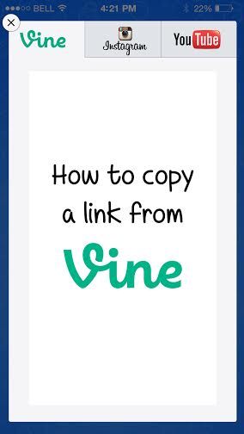

Each tab will have a slide show playing inside it which will let the user know how to copy link from that social network.

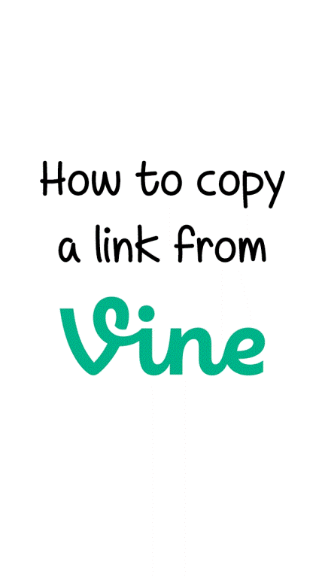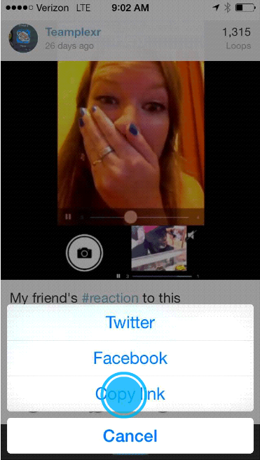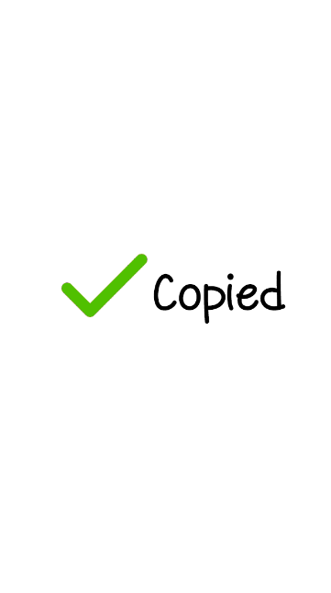

Under the Vine tab we will be playing the slide show with the animation (as shown in the second picture) when the user clicks on the animation we will take them to the next screen and when the user finally clicks on the copy link we will show the “Copied” screen and take them to the next tab. If the user doesn’t click on the animation, we will advance to the next screen after 5 seconds. The whole purpose of these screens is to make the tutorial screens interactive so the user can learn faster.

At any point, the user can exit out of the tutorial screens by simply pressing on the “X” button on the top left corner of this screen. If they want to navigate to the next tutorial, they can do so by tapping the tab at the top. [**Please see the attached gif’s and mp4’s to explain how the slide show works]**

When they click what else we can show them a slide show of these pictures followed by an instruction to paste the link in Plexr.

**If the user exits the app without finishing this process, we will take them to the process next time they enter the app. We will take them to where they left off.**

After completing all the above tasks, a user should know

* What reaction videos are
* Why and how they should share content with their friends
* How to view the reaction video